**PRACTICAL – 7(4)**

**Aim: Write a program to increment the value of one variable by one and**

**display it after one second using thread using sleep() method.**

**SOURCE CODE:**

import java.util.logging.Level;

import java.util.logging.Logger;

import java.util.Scanner;

public class Practical_7_4 extends Thread {

    public *void* run() {

*int* x;

        System.out.println("Enter a variable: ");

        Scanner sc = new Scanner(System.in);

        x = sc.nextInt();

        sc.close();

        x++;

        try {

            Thread.sleep(1000);

        } catch (InterruptedException ex) {

            Logger.getLogger(Practical_7_4.class.getName()).log(Level.SEVERE, null, ex);

        }

        System.out.println("Value of variableis : " + x);

        System.out.println("\n20DCE019-Yatharth Chauhan");

    }

    public static *void* main(String[] *args*) {

        Practical_7_4 t = new Practical_7_4();

        t.start();

    }

}

**OUTPUT:**

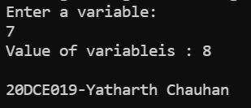

**CONCLUSION:** In this practical we can use the sleep function to stop or say pause the thread for some specific time to execute another thread in the pause time of first thread.